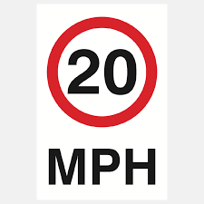
Resident Questionnaire
20 mph Proposal through the Village
Please leave your comments below
Questions | Comments
Do you support the 20 mph?

(Yes/No/Unsure/Don’t mind)
Are there any roads that should be excluded?
If so, please include road names.

If yes to the above, why should these be excluded?

Any other comments

Forms can be downloaded from our website www.somersham-pc.gov.uk
and completed forms emailed to
consultations@somersham-pc.gov.uk
or deliver forms back to:
The Norwood Building, Parkhall Road, Somersham PE28 3HE

Or 50, High Street, Somersham PE28 3JB
Office no. 01487 841359
By 31st July 2022.
Thank you for your time

